
المملكة العربية السعودية
وزارة التعليم
جامعة القصيم
كلية الحاسب
قسم علوم الحاسب

Kingdom of Saudi Arabia
Ministry of Education
Qassim University
College of Computer
Department of Computer Science

CS498
Smart Parking Reservation System Using Mobile Application

Students:
Rafah Saleh Aljabri 412206325
Asayl Faleh Albishri 422205700
Norah Nasser Almutairi 422205743
Mona Saleh Alzunidi 411202232
Ghadeer Mansor Almansor 422205705

Supervisor:
Dr.Njoud Al-Sudays
Contents:
List of Tables …………………………………….……………………….………………………… vi
List of Figures ……………………………………………………………………………………… vii
Abstract …………………………………………………….……………………………………… viii
Chapter One – Introduction:
1.1 Introduction ………………………………………………………………………………………4
1.2 Project Scope ……………………………………………………………………………………...4
1.3 Aim and Objectives …………………………………………………….…………………………6
1.4 Motivation …………………………………………………………………….…………………. 6
1.5 Project Plan and Schedule ……………………………………………………….……………… 7
1.6 Outline of the Report ………………………………………………………………………….... 9
Chapter Two – Literature Review:
2.1 Introduction ………………………………………………………………………………………
2.2 Background …………………………………………………………….…………………………
2.3 Existing Related Systems …………………………………………………………………………
2.4 Contribution ……………………………………………………….……………………………
2.5 Project Methodology…………………………………………….………………………………
2.6 Agile Methodology ………………………………………………………………………………
2.7 Summary …………………………………………………………………………………………
Chapter Three – Problem Analysis
3.1 Introduction ……………………………………………………………….………………………
3.2 Requirement Capture - Problem Specification ……………………….……………………………
3.3 Functional Requirements - System Analysis ………………………………………………………
3.3.1 Requirement Collection ………………………………………………………………………
3.3.2 Requirement Analysis ……………………………………………………………..……………
3.4 Functional Requirements …………………………………………………………………………
3.5 Non-Functional Requirements ………….……….……………………………………………….
3.5.1 Use case …………………………………………………………………………………………
3.5.2 System Sequence Diagram……………………………………………………………………..
3.6 Application Prototype …………………………………..…………………….……………………
3.7 Conclusion ………………………………………………….………………………………………
Chapter Four – System Design
4.1 Introduction ………………………………………………………….…………………………
4.2 System Design Specification ………………………………………………….………………
4.3 Design Architecture ………………………………………………………….…………………
4.4 UML Diagrams (Use Case, Class, Sequence, DFD) ……………………………………….…
4.5 Database Schema ………………………………………………………………….……………
4.6 Pseudocode/Algorithms/Scenarios ……………………………………………………….……
Chapter Five – Implementation and Testing
5.1 Introduction ……………………………………………………………………………………
5.2 Work Environment (Hardware & Software) ……………………………………………….…
5.3 Implementation …………………………………………………………………………………
5.4 Testing and Evaluation ……………………………………………………….…………………
5.5 Results and Discussion ……………………………………………………….…………………
Chapter Six – Conclusion and Future Work
6.1 Conclusion ……………………………………………………………………………….………
6.2 Limitations of the Proposed System ………………………………………………………………
6.3 Future Work ………………………………………………………………….…………………
References ……………………………………………………………………………………………
Appendices ………………………………………………………….………………………………
- Appendix A: Hardware and Software Requirements
- Appendix B: Additional Diagrams/Forms

Chapter One
1 Introduction
1.1 Introduction
Finding a decent parking space is one of a typical driver’s biggest daily challenges, especially in crowded settings, such as universities, hospitals, entertainment centers, or downtown areas. The challenge of finding a parking spot creates waste of time, traffic congestion, anxiety, and fuel consumption. Finding a parking space is troublesome and will only become worse with the increase in vehicles, creating the need for innovative solutions.
Traditional parking management systems would use a hardware approach with systems such as cameras, Automatic License Plate Recognition (ALPR), or ground sensors. These solutions can work in specific situations; however, they often involve a high installation cost, require constant maintenance, and can create privacy-related
issues as the system are constantly monitoring and collecting data. To make these systems even applicable to a large or diverse environment, such as a university campus or downtown area, the camera, ALPR, or ground sensors have a reasonable limit for scalability.
To solve these problems, the Smart Parking System applies a more practical and cost-effective solution based on the philosophy that “the user is the sensor.” Rather than employ costly hardware solutions, the Smart Parking System uses smartphone GPS in combination with simple user interactions by utilizing a “Check-in” button or QR code the user scans when entering or exiting the parking site. When used together (for example, a user checks in upon arrival and checks out upon leaving the parking site), both actions confirm accurate reporting about the user’s actions while helping to reduce infrastructure costs, maintain privacy concerns, and provide valid results for planning and use for administrators.
Within the next section, the project scope will be analyzed to include the target users, the site for pilot testing, the first phase of development, and the potential to broaden or offer new opportunities in larger metropolitan areas.

1.2 PROJECT SCOPE

1.1 Functional Scope
For Drivers (Users):
• Drivers can either register or login with an email or verify their phone.
• It includes an Interactive Parking Lot Map with filters (for example distance, availability, price, options).
• Drivers can reserve a parking space, with the option to extend or cancel.
• Drivers will verify their arrival using GPS, pressing "Arrived" or via a QR scan.
• Drivers will be able to terminate parking via GPS or a QR for the exit.
• Drivers can pay electronically (uncertain whether cash will be allowed this time, for example, wallet or symbol fee for trial) but will offer Slater Mada & Apple Pay in addition or as draw with the first pilot.
• Drivers receive push notifications (timing reminders, time is expired, successful payment, unsuccessful payment).
• Drivers can view their booking history, invoices, and download their receipts in PDF format.
• Drivers can contest fines along with documents (for example: photos/evidence).
• Drivers may set their preferences (for example: usual parking spots, peak hours, etc.).

For Administrators / Operators:
• Administrators/operators maintain site/zone management, capacity, and policies.
• Administrators/operators can generate QR codes (to check in or check out) and link these with gates.
• Administrators/operators will have access to live monitoring (occupancy, revenue, open violations).
• Administrators/operators can create and maintain user roles (admin, operator, viewer).
• Administrators/operators can run reports on occupancy, revenue, and fines (and export - as a CSV or Excel file).

1.2 Non-Functional Scope
• Security: TLS encryption (when in transit), AES-256 (when at rest), and role-based access control (RBAC), audit logs.
• Privacy: complies with Saudi PDPL, retains only Event-Based Data for 90 days.
• Performance: API Response Time < 300ms, notifications sent in near real time.
• Availability: 99.5% uptime during pilot phase.
• Scalability: cloud-based design using Firebase Functions/Node.js with a hybrid database (document & relational).
• Accessibility: bilingual (Arabic / English), screen reader support, and contrast color.

1.3 Geographic Coverage
• Pilot Site: College of Science & Arts (Women’s Campus), Unaizah.
• Potential Scale: hospitals, other universities, big events, and big cities (Riyadh, Jeddah, Makkah, Madinah).

1.4 Restrictions & Policies
• Initial geofence radius = 75m.
• "Arrived" button grace period = 5 minutes.
• Tolerance for being late before penalty = 2 minutes.
• Dispute fine time = 48 hours.
• Anti-cheating: fake locations, one device per account.
• GPS fallback: use QR check in/out when GPS is weak.

1.5 Out of Scope
• Camera/ground sensor installations (not part of the first release).
• Full integration payment gateways launched (starts with a wallet/symbolic fee and launches Mada and Apple Pay in release two).
• Major cities will not be covered from day one (will be covered in phase two after successful pilot).

1.3 Aim and Objectives

The aim of this project is to create a smart parking system that guides drivers toward easily locating and reserving available parking spaces. The system is focused on using the user’s phone (GPS and QR) rather than expensive sensors or cameras to confirm the parking process.

Objectives:

The primary goals of this project are:

1. develop a mobile application for users to register and view available parking areas around them.
2. provide users with the ability to reserve parking, extend their parking reservation, and cancel their parking reservation.
3. use GPS location and QR codes to confirm when the user arrives and departs from the parking spots.
4. incorporate payment processing inside the app to facilitate an easy payment process.
5. create an admin dashboard to manage the parking areas, monitor usage in real time, and process fines, tickets or complaints.
6. protect user information and implement best secure practice/PDPL for data protection.
7. support the Saudi Vision 2030 initiative by using smart solutions and technology to simplify and expedite the parking

1.4 Motivation

1.4.1 Local Problem:

The parking crisis represents one of the most pressing daily challenges in the Kingdom of Saudi Arabia, where finding an available spot during peak hours has become nearly impossible. The process of searching for parking consumes significant amounts of time, increases fuel consumption, and causes considerable fatigue and frustration for drivers.

1.4.2 Global Statistics:

Global studies highlight the severity of this issue, showing that drivers waste more than 55 hours per year searching for parking [1]. In fact, up to 30% of urban traffic is directly attributed to cars circling neighborhoods looking for vacant spots [2].

1.4.3 Economic and Social Impact
- Economic Waste: Financial losses due to fuel consumption and wasted time.
- Environmental Impact: Increased carbon emissions due to unproductive driving.
- Psychological Pressure: Elevated stress levels among drivers.
- Health Implications: Cancellation of visits to vital centers due to parking difficulties.

1.4.4 Alignment with Vision 2030:

The project aligns with Vision 2030's goals of improving quality of life and adopting innovative technology solutions by:
- Enhancing economic efficiency through waste reduction.
- Supporting the transition toward smart cities.
- Improving the experience of citizens and residents.
1.5 Project Plan and Schedule
The Smart Parking project will be executed over 12 weeks, divided into six main phases. Each phase is designed to achieve a specific milestone and ensure continuous progress toward the final system delivery. The timeline considers both development and testing within the academic term.
Phase 1 – Requirement Finalization and Design Planning (Week 1–2)
During the first two weeks, the team will finalize system requirements, clarify functional and non-functional specifications, and complete the architectural design. The geofence areas and QR code flow will also be defined in this phase.
Deliverables:
- Final Software Requirements Specification (SRS)
- System architecture draft (UML diagrams)
- Geofence and QR design plan
Phase 2 – Front-End Development (Week 3–4)
This phase focuses on designing and developing the user interface using Flutter. The team will create the registration, login, map, and booking pages for drivers, ensuring that the interface is intuitive and bilingual (Arabic/English).
Deliverables:
- User login and registration screens
- Interactive parking map
- Reservation and booking module
Phase 3 – Back-End Development (Week 5–6)
The main server logic will be implemented using Firebase (Auth, Firestore, Cloud Functions). This phase includes database integration, real-time data synchronization, and notification setup.
Deliverables:
- Database and authentication setup
- Reservation logic (create, update, cancel)
- Push notification service configuration
Phase 4 – Check-In/Check-Out Mechanism & Admin Dashboard (Week 7–8)
In this phase, the dual confirmation mechanism (GPS + QR) will be developed and connected to the reservation system. The administrative dashboard for live monitoring and policy control will also be implemented.
Deliverables:
- Check-in/out module (GPS and QR scanning)
- Admin dashboard interface
- Live monitoring and data visualization tools
Phase 5 – System Testing and Optimization (Week 9–10)
This stage involves testing each system component (unit testing and integration testing), fixing bugs, and optimizing performance. User testing will also be conducted in the pilot area at the College of Science & Arts in Unaizah.
Deliverables:
- Unit and integration testing reports
- User acceptance testing (UAT)
- Final optimization of GPS and QR accuracy
Phase 6 – Pilot Launch and Documentation (Week 11–12)
In the final two weeks, the system will be deployed in the pilot environment. The team will gather real-time feedback, monitor the system’s performance, and finalize the documentation for submission and presentation.
Deliverables:
- Working Smart Parking prototype
- User feedback and evaluation results
- Final project report and presentation slides

1.6 Outline of the Report
This report is organized into five main chapters, each addressing a different aspect of the Smart Parking system:
- Chapter 1 – Introduction: Presents the background, scope, objectives, motivation, and project plan.
- Chapter 2 – Literature Review: Discusses related research and existing parking systems, highlighting the differences and contributions of the proposed system.
- Chapter 3 – Problem Analysis: Details the system requirements, functional and non-functional analysis, and design planning.
- Chapter 4 – System Design: Describes the architecture, UML diagrams, database schema, and algorithms used in system development.
- Chapter 5 – Implementation and Testing: Explains the implementation process, testing results, evaluation, and provides recommendations for future enhancements.

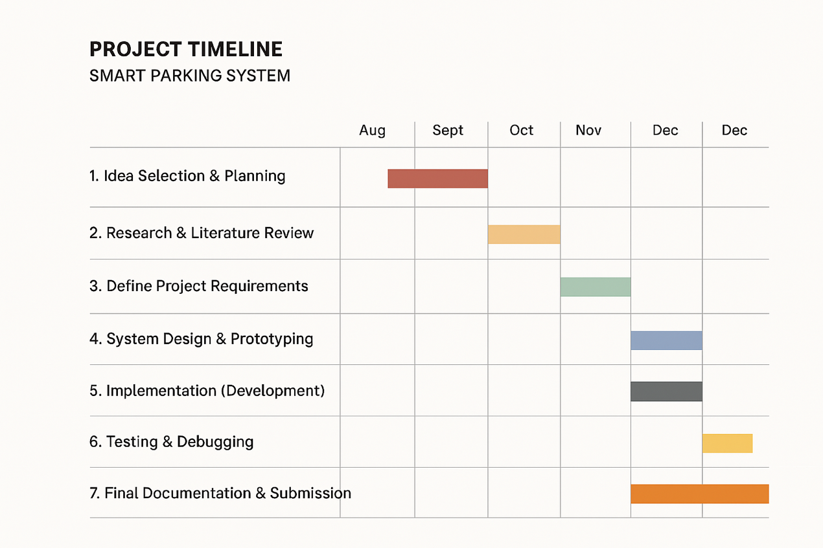
Figure 1.1 The plan of the project

Chapter Two
2 Literature Review
2.1 Introduction
This chapter provides a comprehensive review of previous studies related to smart parking management systems. The objective is to present the technologies and methods currently used to address parking issues in urban environments. It also highlights the advantages and disadvantages of traditional systems such as camera-based monitoring and ground sensors, emphasizing the need for a more cost-effective, user-friendly, and privacy-preserving solution. Moreover, it establishes the foundation for the proposed Smart Parking system, which combines GPS technology and QR codes to deliver a more efficient, scalable, and sustainable solution for modern cities.
2.2 Background
Smart parking systems have emerged as one of the essential components of modern smart cities, aiming to optimize parking space utilization, reduce traffic congestion, and provide drivers with convenient real-time parking availability. These systems integrate various technologies such as the Internet of Things (IoT), sensors, cameras, mobile applications, and cloud-based data analytics to enhance parking management efficiency. Traditional systems typically rely on physical infrastructure, such as sensors installed in parking spots or Automatic License Plate Recognition (ALPR) cameras, to detect vehicle presence and manage availability. Although these systems are accurate, they are expensive and require regular maintenance. With the advancement of smartphone technologies and location-based services (LBS), new opportunities have emerged to implement software-driven solutions that minimize the need for costly hardware. The proposed Smart Parking model utilizes users’ smartphones as sensors by employing GPS tracking and QR codes to confirm vehicle presence. This approach represents a more flexible, cost-efficient, and privacy-compliant solution that can be widely applied across universities, hospitals, and large urban areas.
2.3 Existing Related Systems

2.4 Contribution
The proposed Smart Parking – Smart and Cost-Efficient Version project introduces a novel approach that redefines how parking systems operate in crowded environments. Unlike conventional systems that rely on expensive sensors and camera infrastructures, our solution leverages the user as the primary sensor, combining GPS-based geofencing with manual confirmation (button or QR scan) to verify parking activities.
This concept significantly reduces deployment costs, as no physical sensors or surveillance cameras are required—only software and inexpensive QR codes. It also enhances privacy, since the system does not capture or store vehicle plate images, aligning with modern privacy regulations such as the Saudi PDPL.
From a technical perspective, our contribution lies in integrating multi-layered validation mechanisms (GPS + QR + manual confirmation) to minimize false readings and misuse, while maintaining high accuracy in detecting arrivals and departures. The system also introduces an automated penalty and dispute management module, allowing fair enforcement and user appeal within the app.
Operationally, the platform is designed to be scalable and inclusive, supporting multi-language interfaces (Arabic/English), accessibility features, and cloud-based deployment that ensures over 99.5% uptime for the pilot phase.
In summary, the key contributions of this project are:
• Cost efficiency: Eliminating the need for expensive IoT sensors.
• User-centric sensing model: Turning the driver into the source of validated parking data.
• Privacy preservation: Avoiding camera-based surveillance and ensuring user consent.
• Smart policy enforcement: Introducing automated fines, real-time notifications, and appeal workflows.
• High scalability: Cloud-based architecture ready for large-scale expansion across campuses and cities.
• Enhanced accessibility and localization: Fully bilingual interface with accessibility support.
This combination of low-cost deployment, privacy compliance, and smart automation makes the proposed system a practical and innovative step toward sustainable smart-city parking management in Saudi Arabia.

2.5 Project Methodology
2.5.1 Methodology Selection
We chose Agile methodology for developing the smart parking system. This aligns with appropriate software engineering practice, which advocates for iterative development, continuous delivery, and adaptive planning to respond to changing requirements.
2.5.2 Selection Rational
The decision to adopt Agile methodology is backed by extensive research in software engineering. Research in both industry and academia shows that Agile approaches improve the chances of project success in dynamic systems under continuous change (Standish Group, 2020). The reported benefits of agile methodology are:
- 35% better success than traditional methodologies.
- 40% better alignment of requirements through iterations and feedback.
- Significant reduction in project risk (e.g., continuous feedback).
- Better satisfaction of stakeholders (e.g., sustained engagement) through better visibility via frequent deliverables.
2.5.3 Implementation Framework
By selecting Agile methodology for the smart parking system, we can develop a targeted emphasis on the ongoing refinement of the critical elements of GPS accuracy, real-time data processing, and user interface design. The iterative nature of Agile allows us to account for user feedback and adapt the technology as we develop, thereby maximizing both system performance and the user experience.

2.6 Agile Methodology
2.6.1 Development Framework
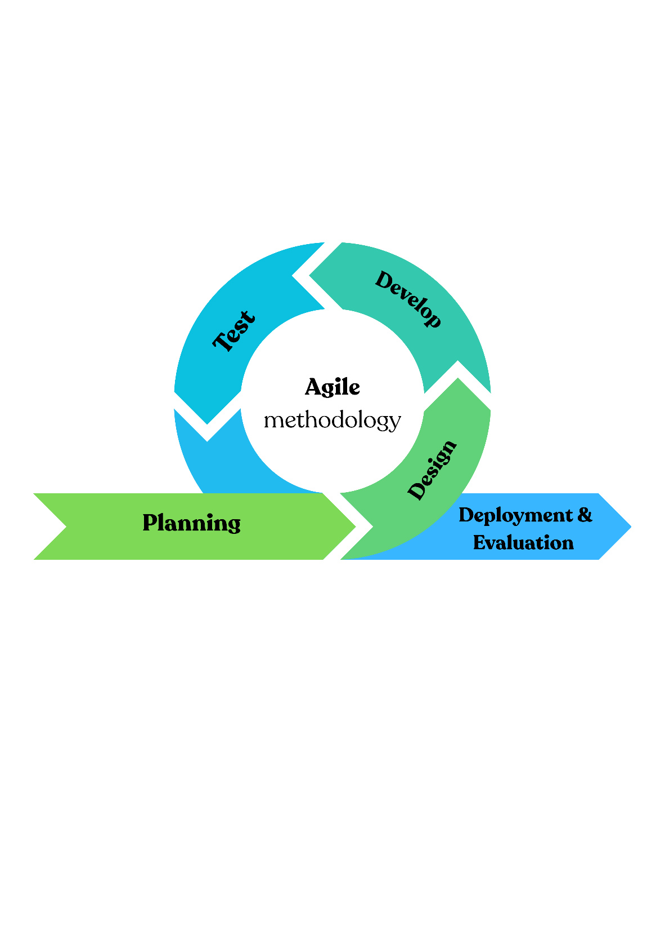
We will apply the structured Agile cycle shown in Figure 2.1, which consists of the following five phases to account for the total system components and design improvements in an iterative design.
Figure 2.1: Agile Methodology Development Cycle
2.6.2 Quality Assurance
Quality verification will be incorporated into each development cycle and will utilize a large variety of testing methods, which include:
- Unit and integration tests of GPS and mapping services.
- Payment processing components security checks.
- Usability tests of the user interface components.
- Performance testing in an authentic user experience.
2.6.3 Expected Outcomes
This implementation of the Agile model is expected to result in, as derived from existing software engineering research:
- Higher quality of the product, balanced out with continuous quality testing and improvement.
- Lower development risk, with possible earlier identification of issues.
- Greater stakeholder involvement through more regular demonstrations of functionality.
- Higher capacity to adapt to emerging technical specificities.
- More timely use of resources through the time-boxed iterations of design.

2.7 Summary
In conclusion, this chapter reviewed the development of smart parking technologies and the current methods used to address parking challenges in urban areas. The drawbacks of hardware-based systems in terms of cost and privacy were underlined, and it was also shown how software-driven solutions can alleviate these deficiencies. The proposed Smart Parking system will adopt a user-centered approach using GPS and QR technologies for a scalable and sustainable solution that aligns with Saudi Vision 2030 goals for intelligent urban infrastructure.

Chapter Three
3 Problem Analysis
3.1 Introduction

3.2 Requirement Capture - Problem Specification
3.3 Functional Requirements - System Analysis

This section presents the main functional requirements for users (drivers) and system administrators involved in the Smart Parking application. The main aim is to ensure the reservation, monitoring, and operation management of the parking application is seamless.

For Users (Drivers ):
1. User Identity Verification: The platform must permit users to create or log into an account using either their email or their phone number of theirs, which must be verified as process requires.
2. Parking Availability Visuals & Sorting: Users will have a map which shows the parking options available but can reorganize it by distance, availability, and cost.
3. Reservations Control: Users will be able to book a parking spot at a specific time and location that can either be extended or canceled based on the policy limitations.
4. Check-In Confirmation: The platform needs to verify that a user is checked in after they arrive by using the GPS geofencing, manually tapping the button that says "Arrived," or scanning the QR code at the entrance.

5. Check-Out Confirmation: The platform will automatically end the users parking session after they have left the geographical area of the geofence, as well as manually tapping the button that said "Exit," or scan the QR code at the exit location.

6. Payment System: Users will be able to complete an electronic payment through a wallet system during the pilot phase, and later through Mada, and Apple pay.
7. Push Notifications: The app should have the capability to send reminders and alerts (e. g. to notify the user that the booking is about to start, close to expiration, payment has been successfully made or not, etc, or not show alerts
8. User Booked History and Invoices: Users will be able to view the booked history for completed bookings, view and print the invoice, and download receipts as a PDF format.
9. Fines and Dispute Process: Users can view fines, and submit a dispute with supporting documentation (i.e., photo or notes) within 48 hours.
10. User Preferences: Users can input their preferred parking locations, hours of peak usage, and options for language. Accessibility tools to support use of screen readers must be included.

For Administrators / Operators:
1. Site and Zone Management:
Admins can create and update parking sites, parking zones, and policies including capacity, hours of operation, policies regarding fines, etc.

2. QR Code Generation:
The system will generate one-of-a-kind QR codes specifically for the entrance and/or exit gates for specific parking zones.

3. Live Monitoring Dashboard:
The dashboard will allow administrators to see the occupancy status, live occupancy, revenue, and open violations.

4. Access Based on Role:
Users can be assigned to three different roles (Administrator, Operator, Viewer).

5. Reporting and Analytics:
Reports on occupancy rates, revenue, fines, and disputed citations will be generated by the System. These reports can be exported in either CSV or Excel formats.

6. Audit Logs:
Any action taken by the administrator (i.e., adding zones, changing policies, and/or resolving disputes) must be logged for future reference and security compliance.

Additional functional requirements:
• Fake Location Detection :The App must be able to detect or prevent users who are attempting to use a fake GPS location by providing a fake GPS location or if it is rooted.
• Backup Method: A QR-style scan should also legitimately substitute check-in/out instead of GPS under situations with weak GPS signal.
• Real-time Event Logging: The system will log and track all events (such as booking, entry, exit, payment, infringements) to establish a secure and trusted event for verification in the case of a dispute.

At the periphery of these functional requirements is the ability to provide a trusted, seamless and safe parking management experience for customers and administrators alike.

3.3.1 System Requirements

This section describes the necessary hardware, along with the software, in addition to networking requirements for implementation and operation of the Smart Parking system.

1. Hardware Requirements

For End Users (Mobile phones):
• An Android cellphone (must be 9.0 or higher) or an iPhone (must be 14.x or higher).
• It must have the option of built-in GPS or capacity to take photo (if geofencing).
• You will need internet access, either wi-fi, 4G, or 5G.
•The app will need to be downloaded onto a device with at least 100 MB available local storage and 3 GB of RAM.

For the Web dashboard’s admin user:
• A desktop or laptop with an up-to-date web browser (i.e. Chrome, Edge, or Safari)
• A dual core processor and at least 4 gigabytes of RAM
•Internet access is required to reconnect to the Firebase back end.

For On-Site Setup (Pilot area):
• Printed QR codes for entry and exit gates (proof of coding, laminated to ensure it is highly visible).
• An optional function is providing a tablet or phone for the gate operators to use to verify their scans in addition to providing the QR code camera and app.

2. Software Requirements

On the client side:
• Flutter SDK for mobile application development.
• Google Maps SDK for geolocation and zone display.
• QR Scanner library built into the mobile app.
• Push messaging via Firebase Cloud Messaging.

Server-Side:
• User login and management via Firebase Authentication.
• Reservation logs and user lists and violation logs in Firestore Database.

• Firebase Cloud Functions (Node.js/Express) managing reservations, violations, and payments with business logic on the server.
• Firebase storage for saving QR codes and paperwork for disputes.
• Analytics dashboard(s) through Looker Studio or Grafana.

Development Tools:
• App development will be done with Android Studio or Visual Studio Code.
• GitHub or GitLab can be used to manage version control and to collaborate.
• All APIs will be tested in Postman.
• The UI/UX can be prototyped using Canva or Figma.

3. Connection and Network Conditions
• Both administrators and users need dependable, high-bandwidth internet access.
• HTTPS/TLS 1.2+ encryption should ensure secure communication.
• Geofenced – GPS can be accurate within 75 -100 meters.
• Firebase and authentication endpoints must be available all the time (minimum uptime of 99.5%).

4. Security and Compliance
• The app and server establish encrypted communication (TLS).
• User data (GPS events, payments) is stored securely with AWS-256 encryption.
• Compliant with Saudi PDPL (Personal Data Protection Law) for privacy and user consent.
• Administrators conduct access control and audit logs are maintained regularly.
• Access control is conducted by administrators, and audit logs are maintained on a regular basis.

5. Scalability and Maintenance
• The pilot implementation of the system can support 500 active users and can scale to the thousands in time.
• Auto-scaled usage could be supported by the serverless architecture.
• All APIs will be tested using Postman.
• The UI/UX prototype can be done in either Canva or Figma.

3. Network and Connectivity Requirements
• Users and Admin must have high speed and reliable internet.
• All communications must be secure using HTTPS/TLS 1.2+ encryption.

3.3.2 User Requirement
Smart Parking System has two primary usage types, drivers (the end-user) and administrator/operator. Each of these types of users will have their own usage requirements for interacting with the system.

A. Driver (End-User) Usage Requirements

1. Register/Authentication
• Drivers should be able to register/create a new account with a password or provide an SMS verified phone number to authenticate their account.
• There should be a secure log-in and log-out process for the user authentication to guarantee their login credentials are encrypted.
• Account verification and password reset should be completed using either the registered email or SMS based account verification process.

2. Discover Parking Lot and Interactive Map Usage
• Drivers should be able to discover an interactive map showing the availability of real-time parking lots.
• The interactive map should allow filtering by distance, price, availability or type of parking zone.
• The driver will be able to view information about each parking lot (name, total capacity, total slots available, pricing and restrictions).
3. Reservations
• Users need to be able to book a parking space ahead of time through the app.
• The system needs to provide users with the reservation confirmation details (location, duration, cost, and start time).
• Depending on timing, drivers will be able to extend or cancel their reservation.
• The app will display a countdown, or remaining time, for active reservations.
4. Arrival & Check-in
• Upon a driver arriving, they will have a confirmation of their arrival by clicking an "Arrived" button, or scanning a QR code at entry.
• The system will confirm the driver is within the radius of the geo-fence (approximately 75m) at check-in.
• In the case of weak GPS signal, we will use the QR code as a backup check-in method.
5. End of Parking (Check-out)
• Drivers will have the ability to end parking either by a button on the app, or scanning a QR code at the exit.
• The system will automatically calculate total usage time/cost next to each button or QR code.
• After successful check-out, the application will provide confirmation message with a digital receipt.

6. Payment Methods
• Users should have the ability to pay electronically through either integrated payment methods (i.e, Mada, Apple Pay, wallet balance) with copies of payment, confirmation and notifying them of success or failure.
• A symbolic or wallet based payment method may be used in the pilot phase prior to full integration.

7. Notifications & Alerts
• Drivers will receive notifications to their phone for various types of key events in-app, which will include confirming bookings, payment reminders, nearing expiry period, etc.
• Users would have access to alerts and notifications about fines, disputes, etc. or information on updates based on the system.
8. Fines and Disputes
• Users will need the ability to see fines levied in-app and be able to dispute them.
• Users should have access to a dispute form so they can provide supporting documents, images of evidence, etc.
• The User should have a decision reviewed, updated, and actioned in-app within 48 hrs
9.History & Records
• Users would gain access to previous history of their parking, reservation info, and payment totals.
• Users will also need access to download their receipt in pdf for any transactions.
• The Template will also allow viewing pending or previous fines (from the same dashboard).

10. User Preferences and Settings
• Users should have the ability to update preferences (preferred parking areas, typical times for parking), and notification management preferences.
• The system must accommodate updating user profile as well (name, vehicle info, phone number).
• Users should have the ability to delete their account permanently if desired.

B. Administrator and Operator Requirements

1. Identity Verification and Access Control
• Administrators with the necessary authorizations must log into line secure admin dashboard using designated credentials.
• The system must allow for a variety of different login privileges and roles for users (admin, operator, viewer).
• The admin must be able to create, edit, and/or deactivate operator accounts.
2. Parking Zone and Zone Management
• The admin must be able to manage parking zones (name, capacity, prices, location boundaries).
• Each parking zone must allow for specific policies (i.e., time limits or time penalties).
• The system must provide a way to empirically log occupancy rates as well as record the instant, a real-time snapshot state of a zone.
3. QR Code and Gate Management
• Admins or operators must be able to create unique QR codes to be sent to each entry and exit gates for parking.
• Each QR code must be placed to relate to its zone for validation.
• The system must record check-ins and check-outs to optimize and/or audit.
4. Monitoring and Dashboard Functions
• The admin dashboard must show live (real-time) data regarding occupancy, revenue, and violations.
• Each of these metrics must be represented on a dashboard with either a chart or table to help visualize key metrics.
• Administrators must have the ability to filter these metrics by date, zone, and/or user.
5. Reporting & Analytics
• Administrators must have the ability to produce reports on the performance of the system, total revenue and user activities.
• Reports (or data exports) must be possible in a CSV or Excel format.
• The system needs to have the ability to visualize historical trends in parking demand over time.
6. Violation & Dispute Management
• An administrator must be able to review complaints submitted by users and respond to the user.
• Admins should be able to change the status of the complaint (approved or rejected) with justification.
• Each incident report must have a full audit trail to provide transparency.
7. Notification Management
• An admin must have the capability to send and control all broadcast notifications to users (or maintenance notifications or policy updates, etc.).
• The system must log all user notifications for audit purposes.
8. System Logs and Audit Trail
• A comprehensive trail record must be kept of all relevant admin activity (edits of zoned, banned users, report exports, etc.).
• Admins must be able to access these logs to help monitor accountability and with the ability to filter.
C. General Requirements (for both roles)
- The system must be bilingual (Arabic and English).
- Both roles will need access to a help center / FAQ section.
- All sessions will time out after a period of inactivity.
- Both user types have the same UI for mobile and web, and it will be responsive.

3.4 Non-Functional Requirements
This section outlines the non-functional requirements for the Smart Parking – The Cost-Efficient Intelligent Version application. These needs represent how users will perceive quality, how the application will perform, and how it will operate.
1. Security
The system will protect users’ information through secure communication (TLS) and rest storage (AES-256) while users' access will be managed through user roles, and all actions will be audited for accountability.
2. Privacy
The system must adhere to personal data protection legislation (PDPL). Users’ permission must be fully expressed to use their GPS location. Information required in fulfilment of the service will be retained, and a user has the right to have their data deleted. Personal data will be retained for 90 days and will then be anonymized.
3. Performance and Availability
The application should be performant and trustworthy, achieving a minimum phase 1 availability of 99.5%. The application's time to produce a response should be no greater than 300 milliseconds, and notifications sent to users will be nearly immediate.
4. Scalability
The proposed system will run on a cloud platform ready for expansion with additional users or parking locations. The database design will be flexible enough to support structured and unstructured data.
5. Usability and Accessibility
The user interface will be basic, easy to understand, and both in Arabic and English versions. The system will also have accessibility features such as screen reader compatibility and high contrast mode.
6. Reliability
The system is designed to work correctly even if there is a weak GPS signal or an interrupted Internet connection while the user is confirming their arrival or departure. The user will be able to confirm their arrival or departure by scanning a QR code during this process.
7. Anti-Fraud and Operational Policies
The system will detect and prevent cheating via fake GPS locations or roots in the device. Each account will be tied to one active device, and if any strange behaviors occur, the system will alert administrators to the issue.
8. Maintainability
The system will be modular in design and allow for the updating of the system without any interruption to endemic user behavior, and will allow for users to log or adjust abnormal acting. System performance will be monitored and logged on a regular basis.
9. Compliance
The system will be compliant with all local Saudi Laws regarding regulated data, data privacy, and regulated electronic payments excluding MADA and Apple Pay.

3.5 Functional Requirements

3.5.1 Use case

3.5.2 System Sequence Diagram

3.6 Application Prototype

3.7 Conclusion
Chapter Four
4 System Design
4.1 Introduction

Chapter Five
5 Implementation and Testing
5.1 Introduction

Chapter Six
6 Conclusion and Future Work
6.1 Conclusion

